

Numericle calulation of avarege radiation:

Theory:

Let consider Earth fixed and radiation always come from the left. The Earth rotated around axis with period 24 hours. This axis also rotate with period 365 days (one year)

earth.wmf

Point E is Edinburgh. Axis is inclined on anlge $α=23°$. Edinburgh geographic latitude is $β=56°$

$x y_{1} z$– coordinate system with origin in the centre of the Earth.

Let $t$ will be time in days. Then day angle:

$$d=2πt$$

It is angle of rotation of the Earth around axis. Year angle:

$$y=2πy$$

It is angle of rotation of the Earth around the Sun.

Vector from the origin that poined to north pole:

$$\vec{a}=\left(-\sin{α}\cos{y,\sin{α\sin{y}}}, \cos{α}\right)$$

$$\left|\vec{a}\right|=1$$

To make rotation of the point E it is need to find two vectors $\vec{a_{1}}$ and $\vec{a_{2}}$ that perpendicular to $\vec{a}$ and each other. They lie in equator plane.

Let use this vectors:

$$\vec{a_{1}}∝\left(-cos{α}, 0, -\sin{α}\cos{y}\right)$$

$$\vec{a_{2}}∝\left(0, -cos{α}, -\sin{α}\sin{y}\right)$$

Normalize:

$$\vec{a_{1}}=\left(\frac{-cos{α}}{\sqrt{\cos^{2}α+\sin^{2}α\cos^{2}y}}, 0, \frac{-\sin{α}\cos{y}}{\sqrt{\cos^{2}α+\sin^{2}α\cos^{2}y}}\right)$$

$$\vec{a_{2}}=\left(0, \frac{-cos{α}}{\sqrt{\sin^{2}α\sin^{2}y+\cos^{2}α}}, \frac{-\sin{α}\sin{y}}{\sqrt{\sin^{2}α\sin^{2}y+\cos^{2}α}}\right)$$

$$\left|{\vec{a}}_{1}\right|=1$$

$$\left|{\vec{a}}_{2}\right|=1$$

Vector then pointed at point E:

$$\vec{n}=\vec{a}\sin{β}+\vec{a_{1}}\cos{β}\cos{d}+\vec{a_{2}}\cos{β}\sin{d}$$

Radiation has constant direction from the left (x derection), then

If $n_{x}≥0$ then there is sun in the sky in Edinburgh (day)

If $n_{x}<0$ then there is no sun in the sky in Edinburgh (night)

Also we have the roof that not horizontal but have angle:

$$γ=30°$$

And also it rotated at angle $φ$:

$φ=0°$ south

$φ=45°$ south-east

$φ=-45°$ south-west.

We need to find vector that is perpendicular to the roof.



Vecors $\vec{u}$ and $\vec{v}$ is perpendicular to $\vec{n}$ an each other. $\vec{u}$ also perpendicular to $\vec{a}$.

Vector that is perpendicular to the roof is

$$\vec{p}=\vec{n}\cos{γ}+\vec{v}\sin{γ\cos{φ}}+\vec{u}\sin{γ\sin{φ}}$$

Power flux is depend on angle ψ of ray

area.wmf

Where P power per unit area on surface. $P_{0}$- power per unit area in rays. $p_{0}$- power per area $S_{0}$

$$\cos{ψ}=p_{x}$$

Where $p_{x}$ is x component of $\vec{p}$ vector (because $\left|\vec{p}\right|=1$)

Solar power flux on distance of Earth orbit is 1367 W/m2 , after atmosphere it is 1020 W/m2

Also absent of light at night must be taken in to accont. Power per unit area of the roof:

$$P=\left\{\begin{matrix}P_{0}p_{x} if n_{x}≥0 and p_{x}≥0 \\ 0 otherwise\end{matrix}\right.$$

Program was made in Matlab that makes such calculation.

Result:

Power vs days, not averaged for $φ=0°$ (south):



The same graph but zommed:



There are peakes of sun radiation in day time and 0 at night.

Avareged powers with interwal 7 days:



Avarege power along all year for South oriented roof is 276.5780 $W/m^{2}$

For South-East is 254.9144



1. Flat-plate double-glassed collector.

It is pipe that is double-glassed. Vacuum prevent losses of heat due to convection with external air.



More hot water in more light so it go up. Then it cooled in heat accumulator and then move down. Pump not need.

Let make estimations for Flat-plate double-glassed collector.

When water move up from bottom to top of the collector its temperature increase from $T_{1}$ to $T_{2}$ and density decrease from $ρ_{1}$ to $ρ_{2}$ and there is equation:

$$ρ_{2} =ρ_{1}-α\left(T_{2}-T_{1}\right)=ρ_{1}-α∆T$$

In the bottom point two pressures not compencete each other:

Pressure of cold water:

- is height of Flat-plate collector.

Pressure from hot water is smaller

$$p=\overline{ρ}gh=\frac{ρ_{1}+ρ_{2}}{2}gh$$

Pressure difference:

$$∆p=\frac{ρ_{1}-ρ_{2}}{2}gh=gh\frac{α∆T}{2}$$

This difference makes water move.

Friction constrain water move. It defined as Hagen-Poiseuille equation

<http://en.wikipedia.org/wiki/Hagen-Poiseuille_flow>

Where $A$ is area of pipe crossection

- water velocity, $R$- pipe radius, $η$- water viscosity, L – pipe length

Part of water volume with length $∆x$ is defined with specific heat $c$:

$$∆E=∆mc∆T=ρ∆Vc∆T=ρA∆xc∆T$$

Where $∆$ means that we consider small volume with length $∆x$.

Energy increasing along pipe:

$E_{x}=\frac{∆E}{∆x}=ρAc∆T$ (1)

If power from sun is:

$$P_{0}=200\frac{W}{m^{2}}$$

Then power per length of pipe is:

$$P_{L}=P_{0}2R$$

This power makes energy increasing along pipe:

$E_{x}=\frac{P_{L}}{t}=\frac{P_{L}L}{V}$ (2)

Combine (1) and (2):

$$∆T=\frac{P_{L}L}{VρAc}$$

In total we have system of 3 equations:

$$∆T=\frac{P_{L}L}{VρAc}$$

$$AV=\frac{∆pπR^{4}}{8ηL}$$

$$∆p=gh\frac{α∆T}{2}$$

There are 3 unknowns: $∆T$ $V$ $∆p$

Let find $∆T$:

$$∆T=\sqrt{\frac{P_{L}L^{2}16η}{cρghπR^{4}α}}$$

For pipe with radius 2 mm:

$$∆T=34 °C$$

$$∆p=567 Pa$$

V=0.0107 m/s

See matlab code for this calculation:

P0=200; % power per m^2

w=1; % width

h=2; % height

N=20; % number of loops

L=N*w+2*h; % pipe length

R=2e-3; % pipe radius

eta=1.1e-3; % water viscosity (Pa*s)

c=4.183e3; % water specific heat

rho=1000; % water density

al1=0.0017; % termal expansion coeeficient

al=rho*al1; % rho=rho1-al*(T-T1);

PL=P0*2*R;

g=9.8;

dT=sqrt(PL*L^2*16*eta/(c*rho*g*h*pi*R^4*al))

A=pi*R^2;

v=PL*L/(rho*A*c*dT)

dp=g*h*al*dT/2

Then more thin pipe then higher temperature but flow decrease.

Also the problem is that we can not make to two long pipe because than friction will be big and velocity will decreas. To solve this it is need to connect pipes in parallel:



2. Evacuated-tube collector

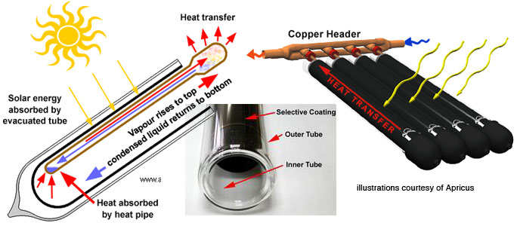

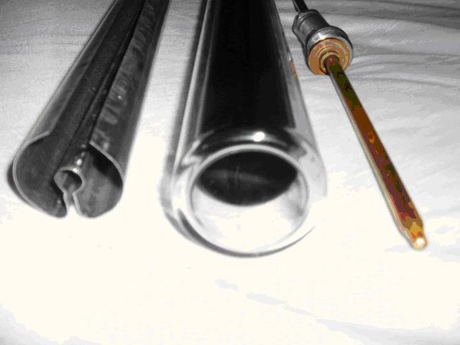

Metal thingh on the left on this photo makes collection of heat from all avaluable arre in one pipe to the tube.

3. Comparison

Evacuated-tube collector has no friction it is advantage. Vapour just move up. Diameter maut be small enough and liquid surface tension must big enough to make liquid uniformly distributed along all pipe. Also disadvantage of Evacuated-tube collector is that if temperature too height then it will be work not effective. Because almost all liquid will be in vapuor and transfer will decrease.

Flat-plate collector is cheaper to do because it is not need to make many evacuated tubes just double-glass one pipe. In evacuated-tube collector is easy to do full covering of all available area. But fat-plate collector has gaps in area that not used.



See cw1_data_wind_frequency.xlsx

Histogram of wind frequency:



X axis – wind velocity m/s,

Y axis number of hour per half year of such wind.

There is per 0.5 year but not per year because data is only for half year.

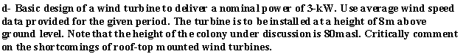

Roof-top wind turbine has many disadvantages:

- it make noise that can be hear in house

- it is impossible to place big enough wind turbine to have about 3 kW power

- roof is close to the propeller, so air not slip at the roof. It is zero velocity on the roof. And then it is not big value for velocity on the roof-top wind turbine.

- near houses decrease wind.

- if roof-top turbin will break, than it can break near houses, dangeros for pedestrians

- the problem of strong mounting to the roof. Roof is not constructed as hard construction

- require special design depending on roof.

Roof-top mounted turbine has many disadvantages. So let use usual wind turbine:



Data for wind height distribution.



Let consider “Trees an houses”

1 foot = 0.3048 meter

1 mile/hour = 0.44704 meter/second

|  |  |  |  |
| --- | --- | --- | --- |
| Height, m | 100*0.3048 | 500*0.3048 | 1200*0.3048 |
| Velocity, m/s | 9.5*0.44705 | 17.4*0.44705 | 20*0.44705 |



The formula is

$$v=2.1h^{0.25}$$

Wind turbine propeller size and power relationship can be estimated as Betz law:

<http://en.wikipedia.org/wiki/Betz%27_law>

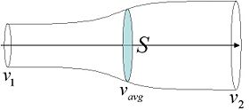

In this law idealized case used, propeller is disc that mot makes air rotation just decrease air velocity.

Short derivation of Betz law:

Conservation law of the mass:

$$∆m=ρv_{1}A_{1}∆t=ρv_{2}A_{2}∆t=ρSv∆t$$

Force is defined by momentum change:

$$∆p=∆mv_{1}-∆mv_{2}=∆m\left(v_{1}-v_{2}\right)$$

$∆m$ is the mass of thin layer of air. This mass is keep constant along the tube. When each time $∆m$ mass of air come into the tube than simultaneously air with mass $∆m$ come out from the tube.

Force:

$$F=\frac{∆p}{∆t}=ρSv\left(v_{1}-v_{2}\right)$$

Power:

$$P=Fv=ρSv^{2}\left(v_{1}-v_{2}\right)$$

Let find maximum possible value of power $P$:

$$P=ρSv^{2}\left(v_{1}-v_{2}\right)=\frac{ρS}{4}{\left(v_{1}+v_{2}\right)}^{2}\left(v_{1}-v_{2}\right)=\frac{ρS}{4}\left(v_{1}+v_{2}\right)\left({v_{1}}^{2}-{v_{2}}^{2}\right)=\frac{ρS{v_{1}}^{3}}{4}\left(1+x\right)\left(1-x^{2}\right)$$

Where $x=\frac{v_{2}}{v_{1}}$

$P\left(x\right)$ is maximal when

$$\frac{dP\left(x\right)}{dx}=0$$

That give quadratic equation with solution:

$$x=\frac{1}{3}$$

Then maximal P is:

$$P_{max}=P\left(\frac{1}{3}\right)=ρS{v_{1}}^{3}\frac{8}{27}$$

If use propeller with radius $R=4.7m$, then its area $S=πR^{2}=70m^{2}$

Wind data gives mean value of velocity:

$$v_{1}=4.98 \frac{m}{s}$$

Air density:

$$ρ=1.22\frac{kg}{m^{3}}$$

Then power:

$$P_{max}=3.1 kW$$

So propeller radius must be about 5 meters:



Top and bottom points of the propeller has different forcies:



This is because of wind gradient. $F_{1}>F_{2}$ If wind in the center is 5 m/s then on the top:

$$5{\left(\frac{8+5}{8}\right)}^{0.25}=5.6 m/s$$

On the bottom:

$$5{\left(\frac{8-5}{8}\right)}^{0.25}=3.9 m/s$$

This difference must be tacked in to accont when design propeller. This difference make loads in propeller between blades. So propeller must be hard enough.



Wind energy generation profile:

See cw1_data_profile.xls

x-data hours

y-data Power, W

The calculation of the power was made using mean value of velocity but more correct way is calculate mean power. If we get 3.1 m radius propeller. Then mean power:

$$〈P〉=〈ρπR^{2}{v_{1}}^{3}\frac{8}{27}〉=ρπR^{2}\frac{8}{27}〈{v_{1}}^{3}〉=3kW$$

Where $〈…〉$ means meaning for all hours of half year



The system consist of:

- wind turbine

- inverter

- accumulators

From site <http://www.sentex.ca/~sxing/generator/generator.htm>

wind turbine price: $8100

inverter price: $ 5700

Let find accumulators price

From power profile it is possible to see that without wind period is about 24 hours. Power is 3 kW, voltage 12 V, then current is 250 A. Then capacity is 250*24=6000A*h

Accumulator LEOCH DJM 12200 parameters:

Price: $426

Voltage: 12 V

Capacity: 200 A*h

Then we need 30 such accumulators, then total price is about $13000

Also power profile has long small wind periods about 600 hours long. This can not be compencated with accumulators. So it is need to use solar panels or diesel generators.

As we can see home use wind generator system has big price about $27000. So it is better to use bigger wind generators with powers about megawatts. And use hydro-accumulation of energy, see detales here:

<http://en.wikipedia.org/wiki/Wind_power#Intermittency_and_penetration_limits>

Alternative way for small power wind turbine is use it’s energy for heating water (using turbular electric heating element). Big volume of hot water can be used as chap energy accumulator. But in this case no electricity generated only hot water for house heating and home using.